AP CSP Python with Robots  Mission 2 Assignment |  | Name:
Mission 2 Introduction
Before you start the objectives, read through the mission introduction. Click on Peripherals to add it to your toolbox. Read about them. Pay attention to peripherals that are input and the ones that are output. You will be quizzed on this later.
Mission 2 Objectives
Complete Objectives 1-5. Click on each CodeBot part as it is introduced so it is added to your toolbox. Take notes in the space provided.
Take the quiz. What is something you learned about static electricity?
Complete Objective 6. What are the two things that happen when you connect CodeBot with the USB cable?
Complete Objective 7. You should see this bar in the lower left corner.
Complete Objective 8 and 9. Click on the Hints and the CodeTrek.
Complete Objective 10. What is the punctuation tip given?
What are the labels of the LEDs?
After Objective 10, submit your LightsOn program to the teacher.
This Mission went over only a few parts of CodeBot. Spend some time exploring your CodeBot. Can you find all the sensors, motors, LEDs, buttons, etc. Look on the top and flip it over to see underneath.
If you need to, review the inputs and outputs from the mission introduction.
When you are familiar with CodeBot and all its parts, go to the “Check your understanding” on the next page.

Label the parts of CodeBot. Indicate if they are used for input or output (or something else).
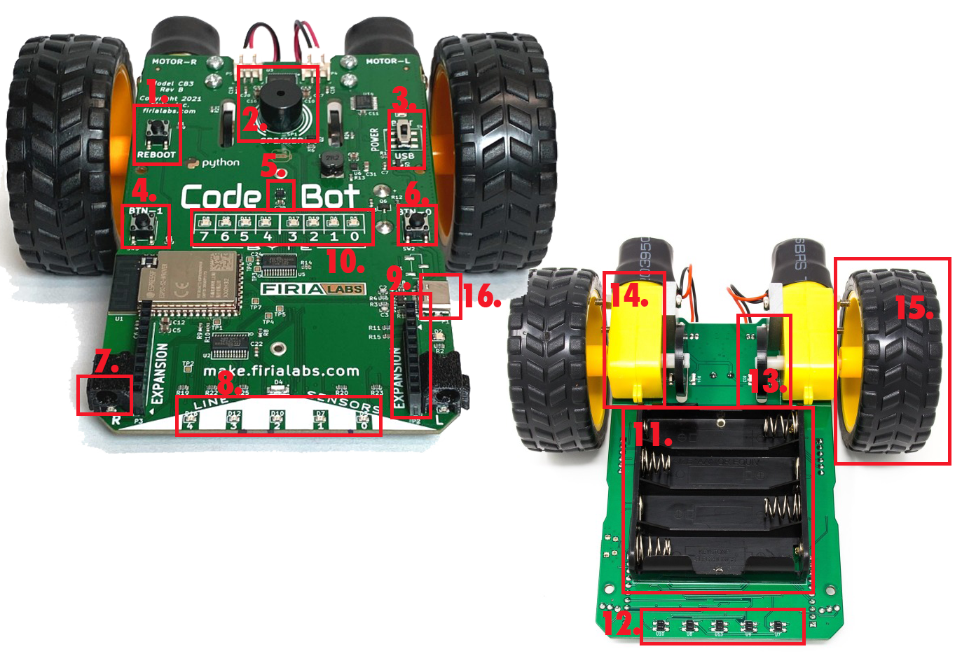
9.
10.
11.
12.
13.
14.
15.
16.

Parts of CodeBot:

- Accelerometer
- Expansion connector
- Battery pack
- User LEDs
- Wheel encoders
- Line sensor LEDs
- Line sensors
- Button 0
- Button 1
- Wheels
- USB connector
- Proximity sensors
- Reboot button
- Speaker
- Motors
- Power switch

